Project Cse326

HTML, CSS, JavaScript

Name : Hiya Jain

Reg No. 12111377

Roll No. RK21YKA42

Topic: MLM Website: Become an MLM guru and recruit others online, via marketing funnel.

Multi-level marketing

**Multi-level marketing** (**MLM**), also called **network marketing** or **pyramid selling**, is a controversial [marketing strategy](https://en.wikipedia.org/wiki/Marketing_strategy) for the [sale](https://en.wikipedia.org/wiki/Sales) of products or services where the [revenue](https://en.wikipedia.org/wiki/Revenue) of the MLM company is derived from a non-salaried [workforce](https://en.wikipedia.org/wiki/Workforce) selling the company's products or services, while the earnings of the participants are derived from a pyramid-shaped or binary compensation [commission](https://en.wikipedia.org/wiki/Commission_(remuneration)) system. An MLM strategy may be an illegal [pyramid scheme](https://en.wikipedia.org/wiki/Pyramid_scheme).

In multi-level marketing, the compensation plan usually pays out to participants from two potential [revenue streams](https://en.wikipedia.org/wiki/Revenue_stream). The first is based on a sales commission from directly selling the product or service; the second is paid out from commissions based upon the wholesale purchases made by other sellers whom the participant has recruited to also sell product. In the organizational hierarchy of MLM companies, recruited participants (as well as those whom the recruit recruits) are referred to as one's *downline* distributors.

MLM salespeople are, therefore, expected to sell products directly to end-user retail consumers by means of relationship referrals and [word of mouth](https://en.wikipedia.org/wiki/Word_of_mouth) marketing, but more importantly they are incentivized to recruit others to join the company's distribution chain as fellow salespeople so that these can become downline distributors. According to a report that studied the business models of 350 MLM companies in the United States, published on the Federal Trade Commission's website, at least 99% of people who join MLM companies lose money. Nonetheless, MLM companies function because downline participants are encouraged to hold onto the belief that they can achieve large returns, while the statistical improbability of this is de-emphasized. MLM companies have been made illegal or otherwise strictly regulated in some jurisdictions as merely variations of the traditional pyramid scheme.

I chose the MLM company as Oriflame.

Screen Shots of my Website

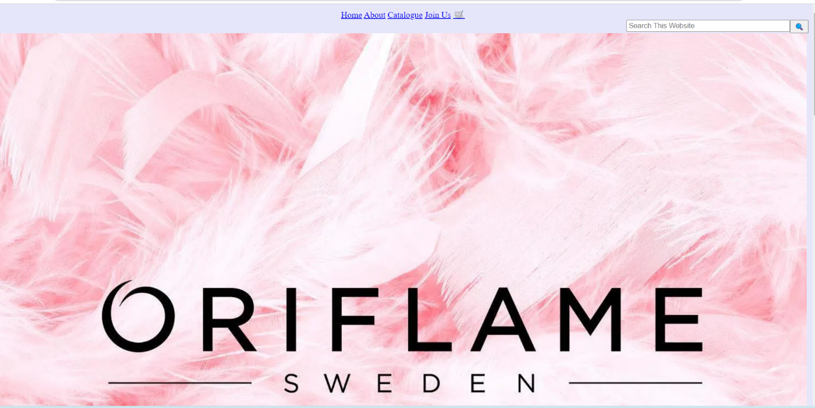

Hyper link is used make Home , About , Catalogue , Join Us , and Cart

<Input> is sued for “search this website” and then is the search button.

An image of Oriflame is placed.



Text and Images of Kalki Koechlin.



Using <iframe> an advertisement of Oriflame is placed.



Images of makeup fragrance and skin care are used as hyper link.

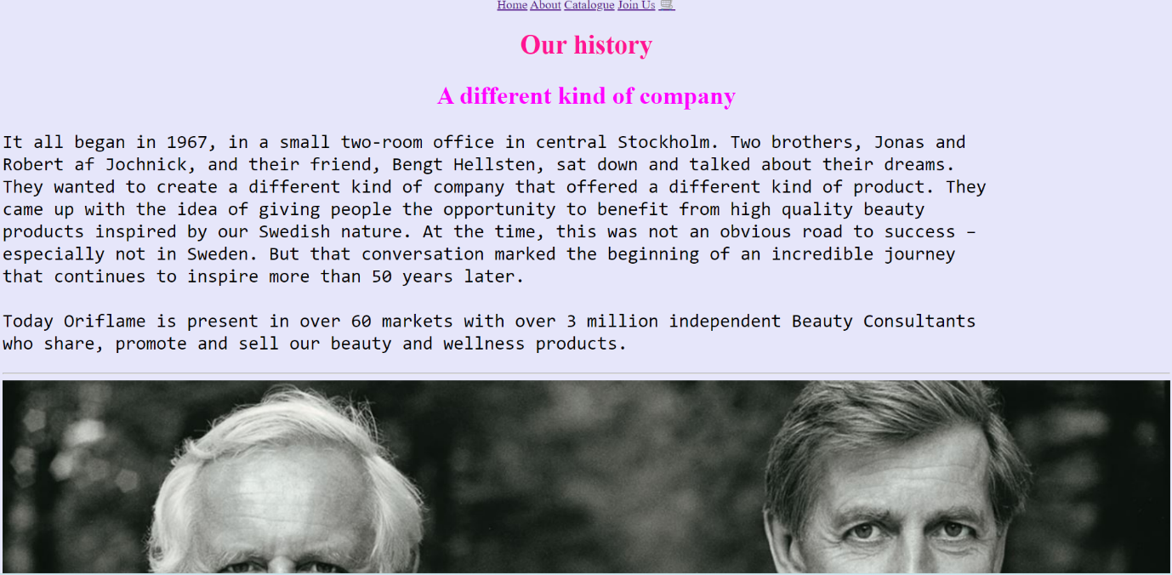

About Page : paragraph tag is used with images.

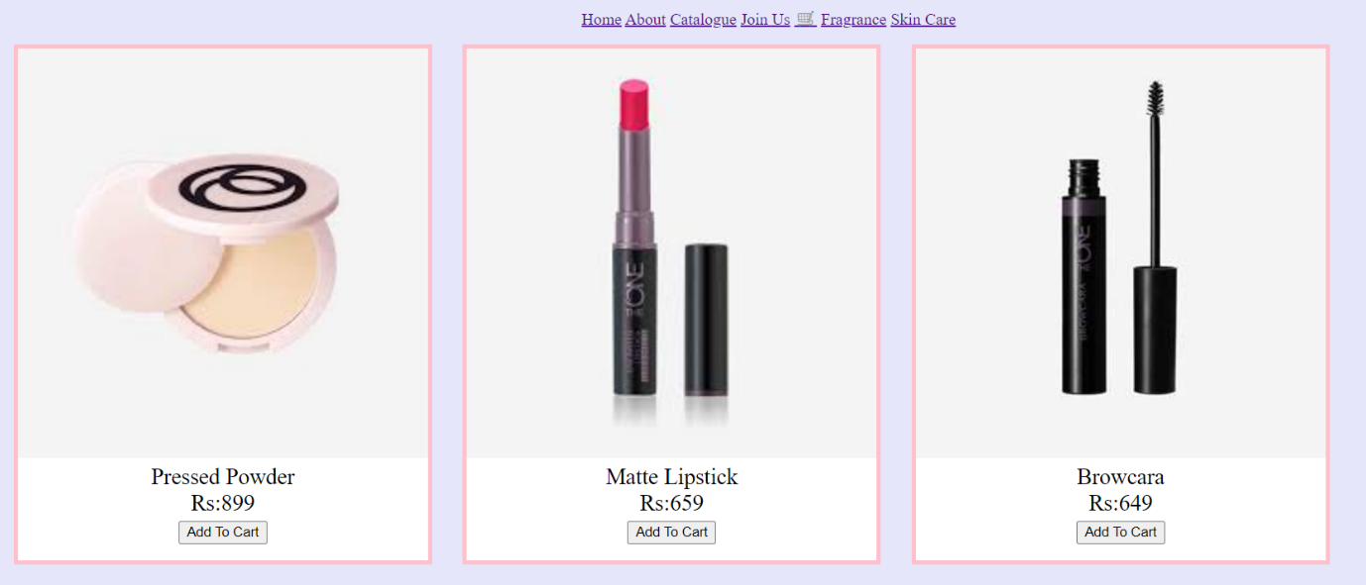

Make up page is opened using image of makeup: make up products are displayed with name , price and Add To Cart button.

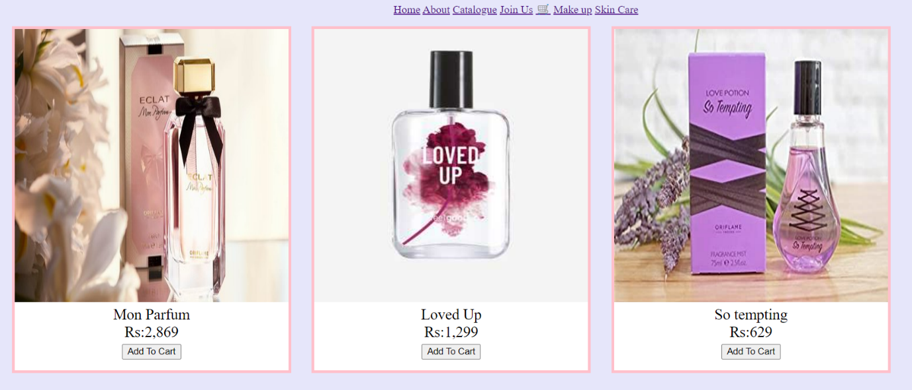

Using the image of fragrance , page of perfumes is opened. Perfumes are displayed with name , price and Add To Cart button.

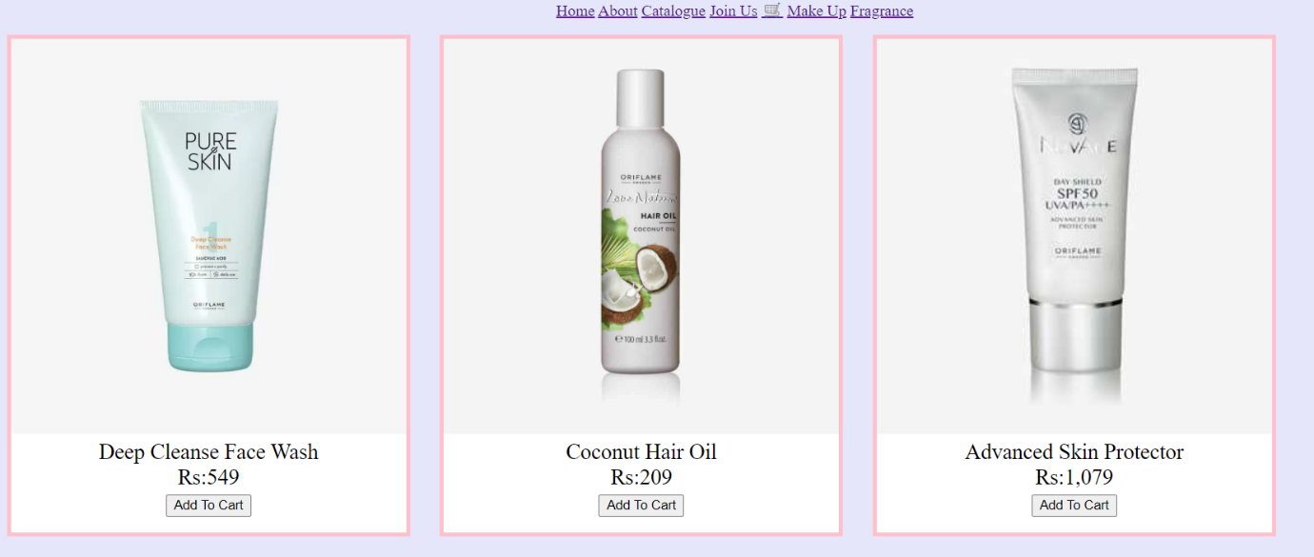

Using the image of skincare , page including skin care products is opened. Skin care products are displayed with name , price and Add To Cart button.



Catalogue : images are added to this page.

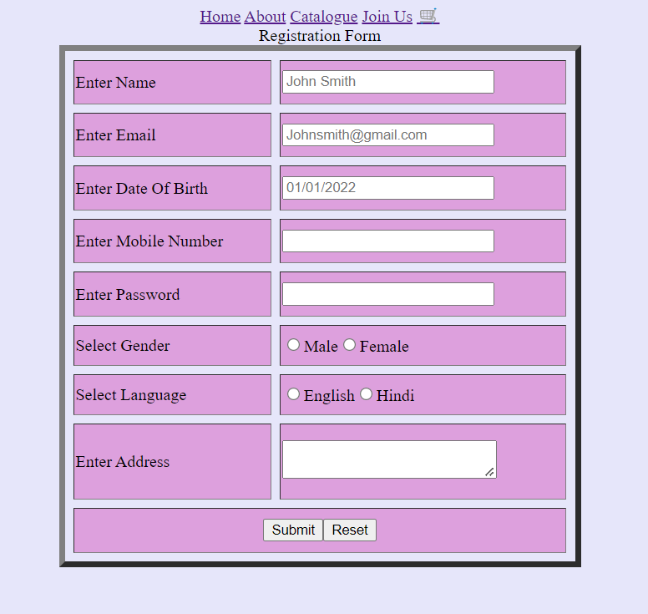

Join Us page : a registration form is made using table.

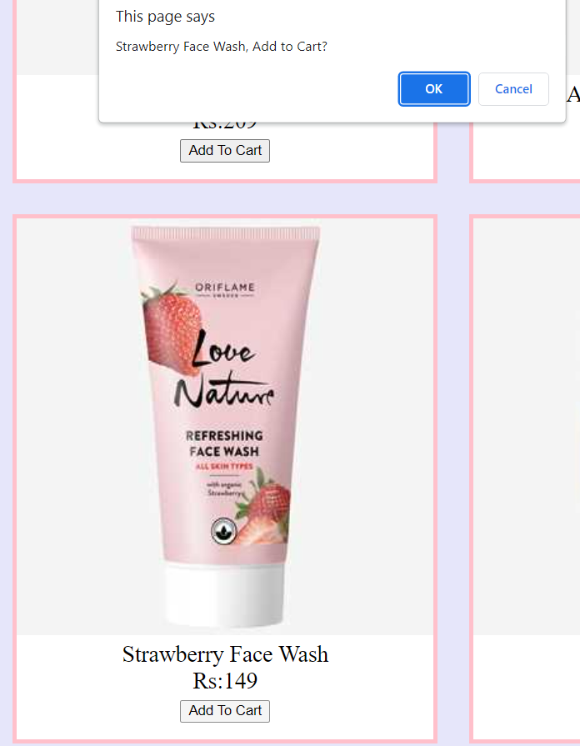

When clicked on “Add to Cart” a pop up is shown with the product name written and asks to add the product to the cart.

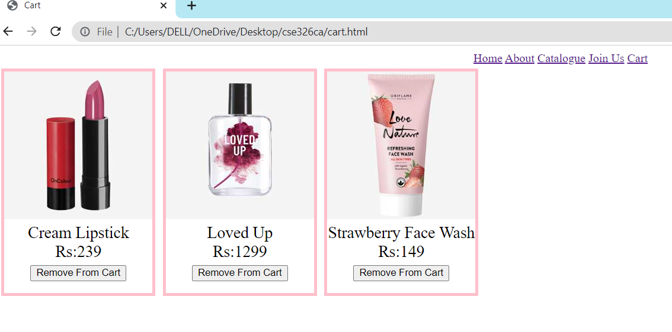

Cart: products are added to cart and can be removed from cart using the button “Remove From Cart”.

My google drive link:

https://drive.google.com/drive/folders/1RkM3OKdv_daGgpq8kc2LIcjPbD_XesoX?usp=sharing